Index.html and venn.js are available from <https://github.com/suksel/Data-Driven-Content/tree/master/venn>

Get index.html and venn.js into a folder called venn under /var/www/html/venn like below

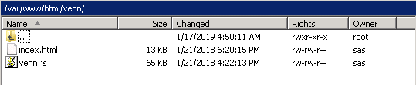

Then in a VA report use the Data Driven Object and change the location it points to as below <http://sasserver.demo.sas.com/venn/index.html> obviously replacing “sasserver.demo.sas.com” with your server 😊

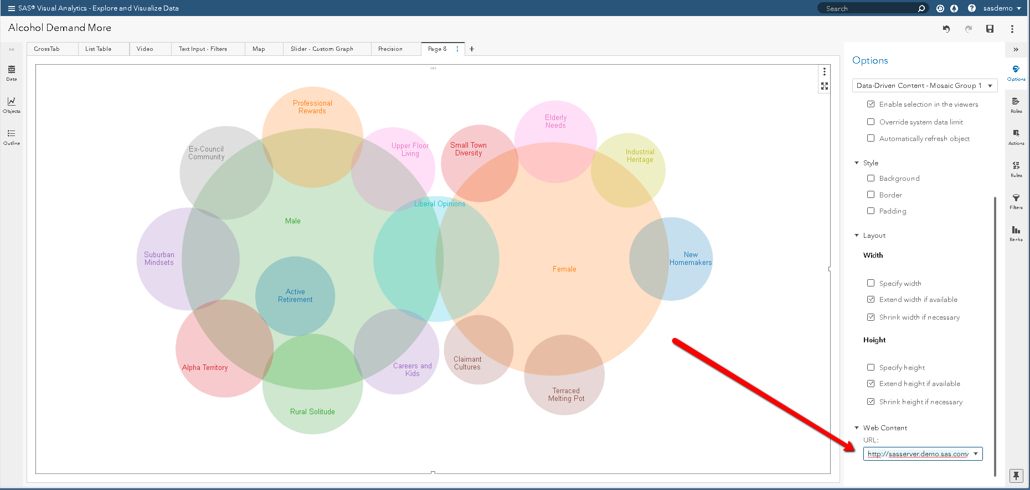

Then to populate the chart use and data – my example here is using the Alcohol Demand data. If I remember correctly it needs 3 variables to work. I chose Mosaic Group Gender and Hours in Employment. Order of variables is important (it’s a pretty basic example) 😊

